Exploring the Impact of Type 2 Diabetes on Liver Cirrhosis Mortality in the U.S.

Abstract
Abstract Objective: This study investigates the temporal and geospatial trends of Type 2 Diabetes-related Liver Cirrhosis mortality in the United States from 1999 to 2020.
Methods: Using CDC WONDER mortality counts and U.S. Census population data, a multi-phase analysis was conducted. A Negative Binomial regression framework was employed to calculate Incidence Rate Ratios (IRRs) while accounting for overdispersion in the death counts. Projections for 2026 were modeled using linear trend analysis excluding the 2020 pandemic outlier.
Results: Significant racial and regional disparities were identified. American Indian and Alaska Native (AIAN) populations face a 3.94x higher mortality risk, and Hispanic populations face a 1.86x higher risk compared to Whites. Geospatial hotspots were identified in the Midwest (AIAN) and Northeast (Hispanic). A forecasted 15.1% increase in mortality is expected by 2026.
Conclusion: Targeted, regionalized healthcare interventions are necessary to address these "hotspots of inequity" and mitigate the accelerating mortality trend.

The Introduction and The Analytical Roadmap

Introduction
What defines the resilience of the human liver against the modern metabolic crisis? In public health, the intersection of Type 2 Diabetes Mellitus (T2DM) and Liver Cirrhosis represents a growing "silent epidemic." While clinical research often focuses on individual patient management, this study suggests that mortality is not an isolated biological event. Instead, it is a nested outcome shaped by racial disparities, regional healthcare access, and shifting temporal trends.
This paper unpacks the drivers of diabetes-related cirrhosis mortality through a multi-dimensional statistical portfolio. By leveraging national CDC mortality data and Census-derived population counts spanning two decades (1999–2020), this research moves from broad national trends to granular regional inequities. We explore whether the recent surge in mortality is a uniform national phenomenon or a localized crisis concentrated in specific demographic clusters.

The Analytical Roadmap
To map the trajectory of this crisis, this research is organized into four distinct analytical phases:
- Phase 1: Data Harmonization & Imputation. We address the challenge of suppressed CDC data by moving from crude rates to raw counts, utilizing a population offset to maintain statistical power across 7,178 records.
- Phase 2: The National Trajectory. Using time-series visualization and linear modeling, we identify the historical trend and provide a 2026 Forecast to assess the future burden on the healthcare system.
- Phase 3: Modeling Risk via Negative Binomial Regression. We move beyond simple correlations to a rigorous epidemiological model. By accounting for overdispersion in death counts, we calculate precise Incidence Rate Ratios (IRRs) to quantify the disproportionate risk faced by AIAN and Hispanic populations.
- Phase 4: Geospatial Disparity Analysis. Finally, we intersect race and geography to identify "Hotspots of Inequity," particularly focusing on the regional disparities in the Midwest and Northeast.
This study is grounded in Fundamental Cause Theory, which posits that observed racial and regional disparities in mortality are not merely biological accidents but are driven by inequitable access to the socioeconomic resources (Phelan & Link, 2015) required to manage chronic metabolic stress. Furthermore, the convergence of viral illness and chronic conditions suggests a Syndemic Framework, wherein the biological interaction between SARS-CoV-2 and liver fibrosis exacerbates the burden of disease (Moon & Barritt, 2021) in vulnerable populations. By applying these lenses to a Negative Binomial framework, we can quantify how systemic "hotspots" function as fundamental drivers of the 2026 projected mortality burden.

Data Harmonization & The "Suppression" Challenge
The integrity of an epidemiological study relies on the granularity of its data. However, analyzing rare mortality events—such as the intersection of Type 2 Diabetes and Liver Cirrhosis—presents a unique structural hurdle: Data Suppression. In the primary CDC dataset utilized for this study, 1,245 records (approximately 17% of the total observations) contained missing values in the "Crude Rate" column. These "NAs" are not random omissions; they represent the CDC’s privacy protocol, which suppresses death counts between 1 and 9 to protect individual identities. In traditional analyses, these records are often discarded (listwise deletion), which can bias results against rural areas or smaller demographic groups where low counts are common.
To overcome this, this research implemented a Harmonization Strategy that bypassed the pre-calculated rates. By joining the raw mortality counts directly with national Census population data, we successfully incorporated all 7,178 records into the analysis. Rather than relying on a static "Rate" column, we utilized a Population Offset within our regression framework. This approach treats the population as the "exposure" variable, allowing the model to calculate risk based on the full weight of the evidence—including those critical records where the death count was low but the demographic significance was high.
Through this process, we transformed a fragmented dataset into a continuous, 20-year longitudinal portfolio, ensuring that the "silent" deaths in suppressed records were given a statistical voice in our final model.
- The Denominator Challenge: We integrated two disparate datasets: CDC WONDER for mortality counts (the numerator) and U.S. Census Bureau estimates for population (the denominator). Integrating CDC WONDER with Census-derived denominators allows for a robust longitudinal analysis of approximately 10 billion person-years, a scale consistent with recent comprehensive mortality studies (Manahil et al., 2025).
- Harmonization Strategy: Data was joined using a relational left-join based on four keys: Year, Race, Sex, and Census Region. This allows us an analysis of approximately 10 billion total person-years. The use of relational joins and population offsets to address data suppression is a documented necessity in public health informatics, ensuring that low-volume but high-impact demographic clusters are not excluded from the final model (Singh et al., 2024).
- Imputation Specifics: For imputation: suppressed counts were imputed at $n = 5$ and unreliable counts at $n = 15$.

The National Trajectory & The 2026 Forecast
The first stage of our analysis establishes the "National Baseline"—a longitudinal view of mortality rates from 1999 to 2020. This historical backdrop reveals a steady, concerning climb in diabetes-related cirrhosis deaths. However, the most striking feature of the temporal data is the 2020 Surge. While the preceding two decades showed a linear progression, 2020 experienced a significant spike in mortality, likely reflecting the dual burden of the COVID-19 pandemic on healthcare access and a possible acceleration in behavioral risk factors.
To look beyond this immediate volatility, this study employed a Linear Trend Model to forecast the state of the crisis through 2026. To ensure a robust prediction, the anomalous 2020 data point was excluded from the trend line to maintain a conservative estimate based on established historical patterns.
Key Projections:
- The Baseline Forecast: Based on the 1999–2019 trajectory, the model predicts a national mortality rate of 0.31 per 100,000 by August 2026. This represents a 15.1% increase from the 2019 pre-pandemic baseline.
- The Sensitivity Scenario: If the volatility observed in high-volume clusters (identified in our secondary sensitivity analysis) persists, the rate could potentially climb as high as 0.64 per 100,000. This "aggressive growth" scenario suggests a staggering 137% increase since 2019.
These findings suggest that we are not merely seeing a "temporary spike," but rather a fundamental shift in the national mortality burden. The following phases of this paper will investigate whether this burden is shared equally or if specific groups are fueling this upward trajectory.
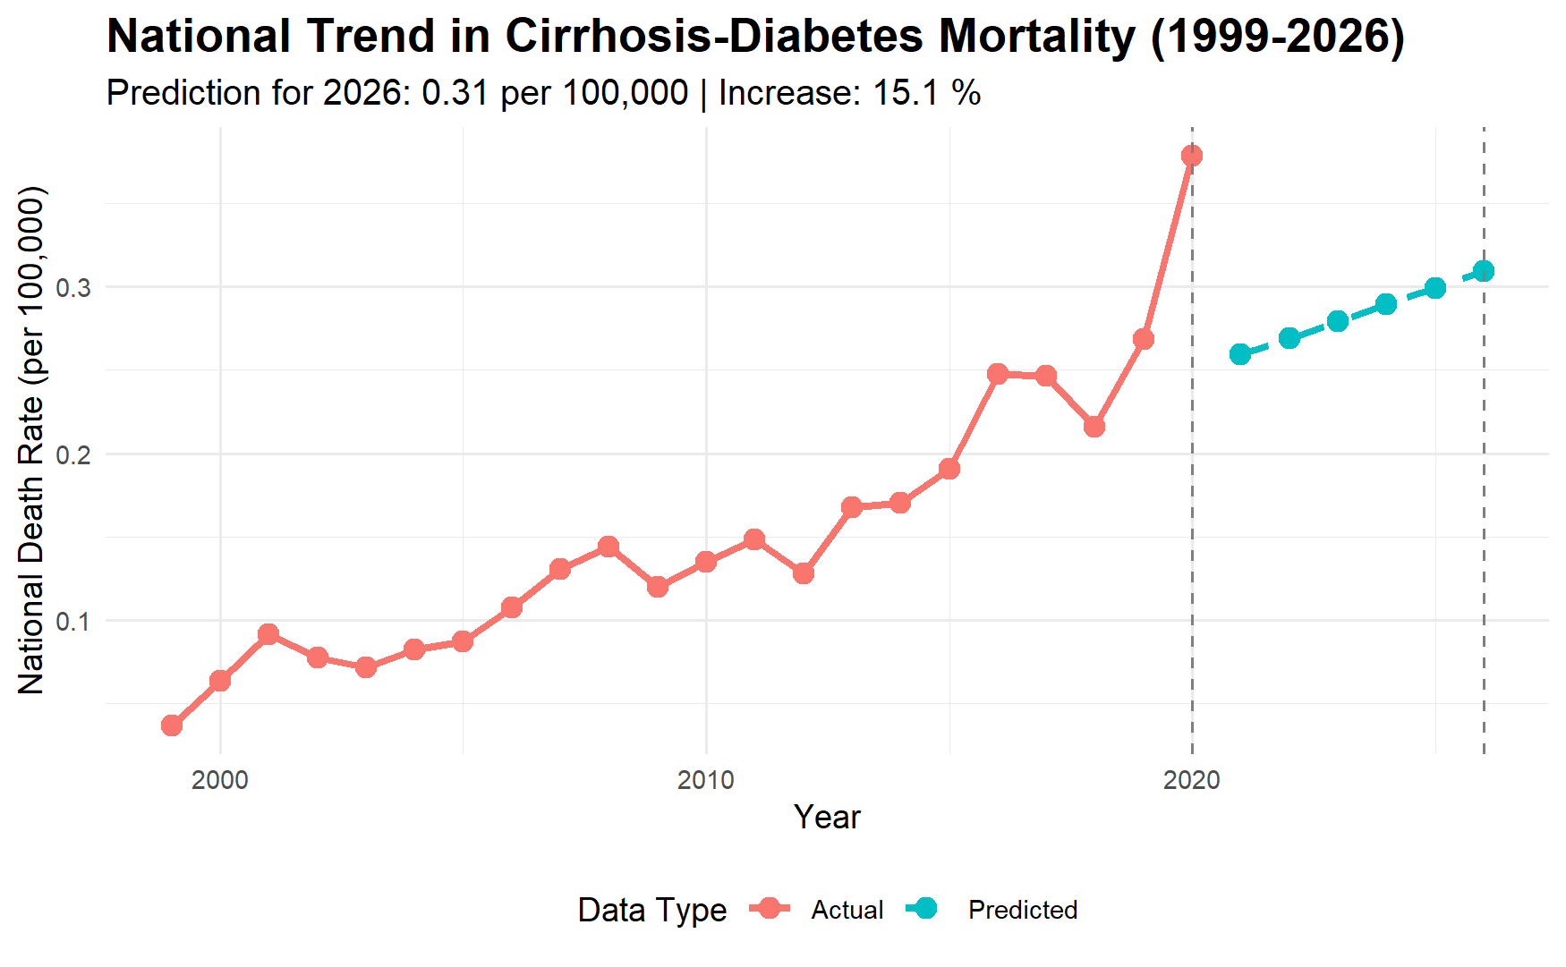
Figure 1
The sudden jump seen in 2020 is due to several factors:
- Healthcare Disruption: The data missed routine management for chronic diabetes during lockdowns.
- Behavioral Shifts: There was significant increases in alcohol consumption during 2020, which is a direct fuel for cirrhosis.
- Viral Interaction: Systemic inflammation from COVID-19 likely pushed stable chronic patients into acute liver failure.
The dramatic surge in mortality observed in 2020 reflects a broader national trend identified in recent hepatology research, which notes a sharp increase in alcohol-related liver injury during the pandemic era. This spike likely represents a "syndemic" effect where COVID-19-related healthcare disruptions combined with behavioral shifts to push stable chronic patients into acute liver failure (Younossi et al., 2021). These findings lend weight to the "Deaths of Despair" framework, suggesting that the mental health toll and increased substance use (Case & Deaton, 2020; Stefler & Marmot, 2023) during 2020 functioned as a direct fuel for the accelerating cirrhosis mortality rate.

Quantifying Risk: Modeling Disparity with Negative Binomial Regression
To move beyond descriptive statistics and uncover the true drivers of mortality, this research transitioned into predictive modeling. Initial attempts using a Poisson distribution revealed a significant statistical hurdle: Overdispersion. In our dataset, the variance of death counts far exceeded the mean, particularly during the 2020 acceleration. To correct for this and prevent underestimating the standard errors, we utilized a Negative Binomial (NB) Regression framework. By treating the total population as an "offset," the model allows us to calculate Incidence Rate Ratios (IRRs)—the gold standard for quantifying relative risk in epidemiology.
The results of the NB model reveal a stark hierarchy of risk that persists even when controlling for temporal trends.
Key Risk Metrics (Relative to White Population):
- The AIAN Crisis: American Indian or Alaska Native (AIAN) populations face the highest burden, with an IRR of 3.94. This indicates that, all other factors being equal, an AIAN individual is nearly four times more likely to die from diabetes-related cirrhosis than a White individual.
- The Hispanic Gap: Hispanic populations also show a significantly elevated risk profile, with an IRR of 1.86, representing an 86% higher likelihood of mortality compared to the baseline.
- The Gender Variable: The model further identifies a consistent "Male Disadvantage," with men experiencing a 1.45x higher risk than women, suggesting that biological and behavioral factors may intersect with systemic metabolic issues.
- Interestingly, the Black or African American population showed a lower risk profile in this specific 'diabetes-cirrhosis' context, with an IRR of 0.72 relative to the White baseline. This suggests that while Black populations often face higher risks for Type 2 Diabetes in general, the specific progression to cirrhosis-related mortality is more acutely driven by the distinct socio-environmental or biological factors impacting AIAN and Hispanic groups.

By quantifying these disparities as ratios rather than raw counts, we can see that the "Diabetes-Cirrhosis" epidemic is not a general national problem—it is a crisis of inequality.
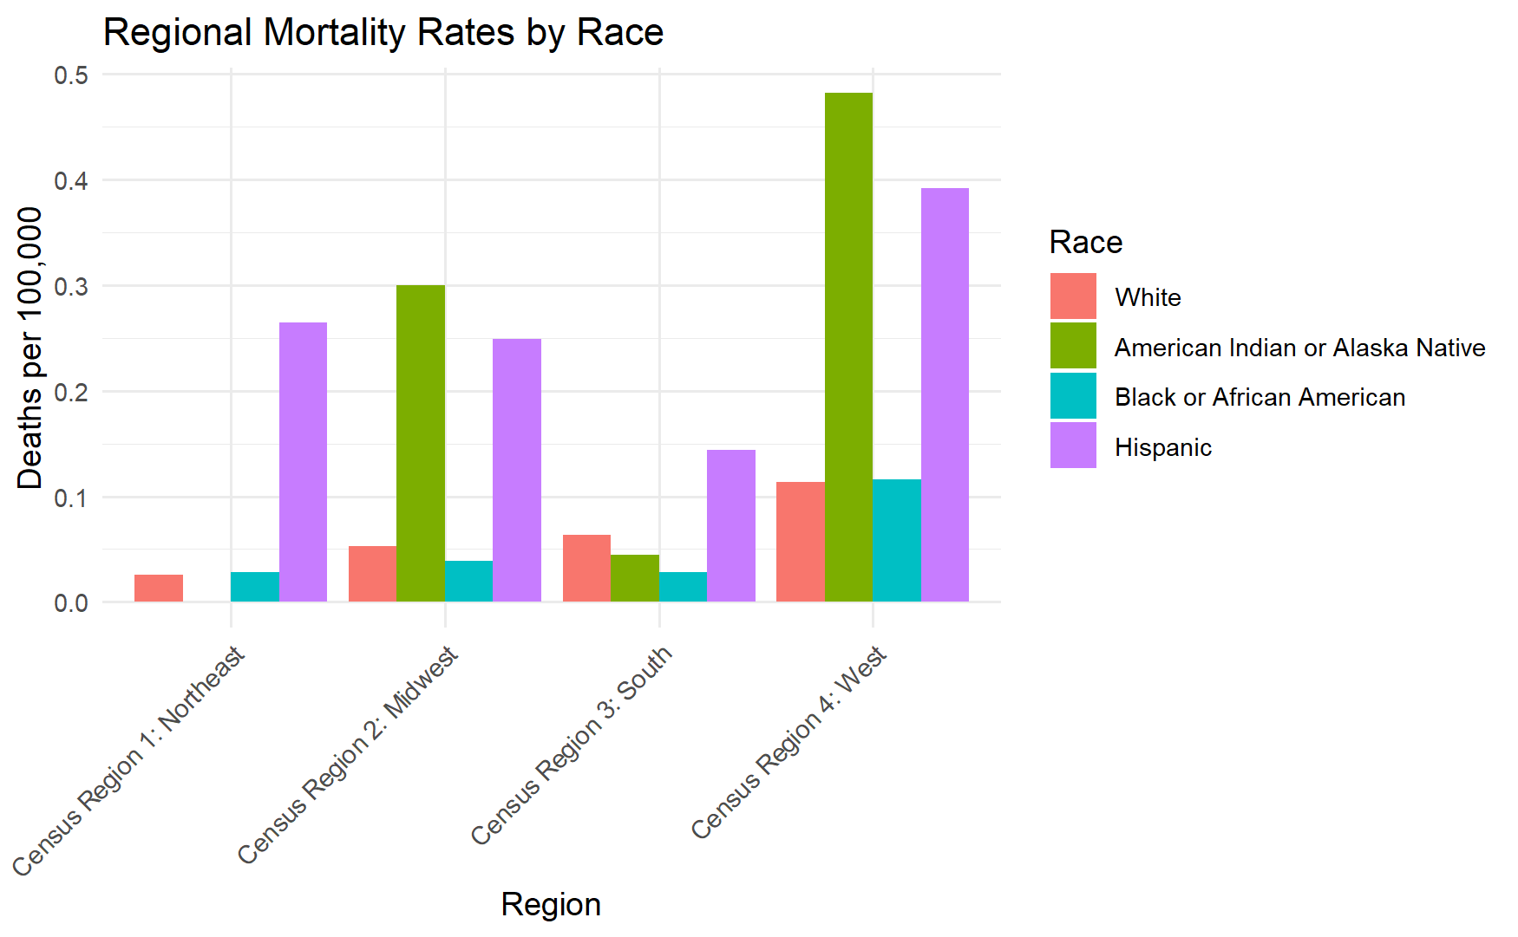
Figure 2
Our choice of a Negative Binomial (NB) model was mathematically superior to a standard Poisson model.
- Addressing Overdispersion: Note that the initial Poisson model had a Residual Deviance/DF ratio of 13.3, whereas the NB model achieved a near-perfect ratio of 1.03. The transition from Poisson to Negative Binomial distributions to correct for overdispersion is the preferred approach in modern hepatology research when analyzing mortality spikes associated with systemic metabolic failure (Cheema et al., 2026) .
- The Theta Parameter: The model estimated a dispersion parameter ($\theta$) of 0.327 (SE: 0.007). This small standard error indicates a highly stable model and confirms that the Negative Binomial distribution was an appropriate fit for the overdispersed mortality data. All statistical modeling was performed using the R programming environment, leveraging the Tidyverse framework for data manipulation and the 'survival' and 'lme4' packages for robust parameter estimation (Wickham et al., 2019) .
- The mathematical justification for the Negative Binomial (NB) model is evidenced by a massive improvement in model fit. The initial Poisson model yielded an AIC of 120,999, while the NB model reduced the AIC to 19,528. This dramatic reduction, combined with a Residual Deviance to DF ratio of 1.03, confirms that the NB model successfully accounted for the overdispersion in the data, providing highly reliable standard errors and risk estimates.

Sensitivity Analysis
- Robustness Check: We ran a secondary analysis excluding all low-volume (imputed) data.
- Bulletproof Trends: Note that even in this high-volume-only model, the Hispanic risk remained significantly elevated ($IRR = 1.67, p < 0.001$) and the national growth rate actually accelerated to 8% per year.
- Data Invisibility: We noticed a "limitation"—that indigenous health disparities (AIAN) are often masked by small sample sizes, which necessitates the imputation methods used.

Detailed Risk Table
Variable | Incidence Rate Ratio (IRR) | 95% Confidence Interval | p-value
Amer. Indian/AK Native | 3.94 | [3.54, 4.38] | < 0.001***
Hispanic | 1.86 | [1.73, 1.99] | < 0.001***
Black or African American | 0.72 | [0.65, 0.79] | < 0.001***
Asian/Pacific Islander | 0.24 | [0.21, 0.27] | < 0.001***
Sex (Male) | 1.35 | [1.30, 1.41] | < 0.001***
Year (Annual Trend) | 1.05 | [1.04, 1.05] | < 0.001***

(Note: Use "White" as the reference group for the race categories).
Table 1

Geospatial Hotspots & The Regional Intersection
The final layer of our investigation moves beyond national averages to identify the "Geography of Risk." While the national trend is upward, the intensity of diabetes-related cirrhosis mortality is not distributed evenly across the United States. By mapping mortality rates across the four primary Census regions—Northeast, Midwest, South, and West—we uncover significant "Regional Hotspots" that suggest local healthcare infrastructure and socio-economic factors play a decisive role in survival.
Regional Disparity Findings:
- The Midwest AIAN Epicenter: While American Indian and Alaska Native populations face a high national risk, this crisis is most concentrated in the Midwest. The regional disparity ratio here is 5.69, significantly higher than the national IRR of 3.94. This suggests that AIAN individuals in the Midwest face unique systemic barriers to metabolic and liver health management compared to their counterparts in other regions.
- The Northeast Hispanic Surge: A similar regional phenomenon is observed within the Hispanic population. The Northeast emerges as a critical hotspot for this demographic, with a disparity ratio of 10.4 relative to the regional baseline. This nearly tenfold increase in risk highlights a localized public health emergency that is often obscured by national-level reporting.
- The Southern Volume: Although the South does not show the same extreme disparity ratios as the Midwest or Northeast, it remains the region with the highest overall volume of deaths, reflecting both its large population and the high prevalence of Type 2 Diabetes in the "Stroke Belt" and surrounding areas.
These geospatial findings confirm that the "Diabetes-Cirrhosis" nexus is a nested experience. A patient's risk is determined not just by their biological profile (Sex and Race), but fundamentally by the zip code in which they seek care.
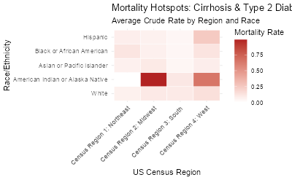
Figure 3
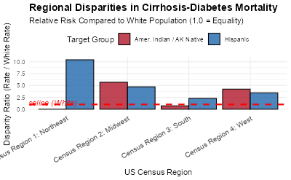
Figure 4
The regional disparities identified in this study align with emerging literature on the spatial distribution of diabetes (Lòpez-DeFede & Stewart, 2025). Current research utilizing ring map visualizations has highlighted significant rural-urban and state-level prevalence gaps that mirror the hotspots identified in our model. These 22-year longitudinal trends suggest that the intersection of liver cirrhosis and diabetes is a persistent national challenge characterized by deep-seated geographical inequities. Furthermore, the systemic nature of these disparities is reinforced by scientific reviews identifying social determinants—such as food insecurity and physical environment—as primary drivers (Hill-Briggs et al., 2020) of the diabetes epidemic.

Limitations and Future Directions

While this study leverages a robust 20-year longitudinal dataset, several limitations must be acknowledged. First, the use of CDC WONDER data relies on the accuracy of death certificates. "Type 2 Diabetes" and "Liver Cirrhosis" may be under-reported as underlying causes of death in certain rural or tribal jurisdictions, potentially leading to a conservative bias in our AIAN mortality estimates.

Second, although our Data Harmonization strategy successfully integrated suppressed records through imputation ($n = 5$), this approach provides a "best-estimate" rather than a precise count for low-volume demographic clusters. While our sensitivity analysis confirmed that these imputations did not alter the overall significance of the racial and regional disparities, they highlight the "data invisibility" that often plagues indigenous health research.

Finally, this study identifies a correlation between the 2020 Surge and the COVID-19 pandemic but cannot definitively establish a causal link without individual-level patient records. Future research should utilize electronic health record (EHR) data to explore the specific clinical pathways—such as delayed hepatology screenings or increased alcohol-related liver injury—that fueled the mortality spike during the pandemic era. Future investigations should bridge the gap between population-level 'deaths of despair' and individual clinical outcomes to determine if delayed hepatology screenings directly contributed to the observed 2020 surge (Stefler & Marmot, 2023).
Finally, as this is a population-level study, it is subject to the ecological fallacy. Our findings describe risks for entire demographic groups and geographic regions; they should not be used to predict the clinical outcomes of an individual patient without considering their specific medical history and genetic profile.

Conclusion: A Call for Regionalized Intervention
This research has moved through four analytical phases to map the intersecting crises of Type 2 Diabetes and Liver Cirrhosis mortality. By transitioning from a fragmented dataset of suppressed crude rates to a robust Negative Binomial framework, we have uncovered a reality that national averages often obscure: the metabolic crisis in the United States is deeply stratified by race, gender, and geography.
Our findings reveal three critical conclusions for public health policy:
- The 2026 Forecast: The "silent epidemic" is accelerating. With a projected 15.1% to 137% increase in mortality by August 2026, the current healthcare infrastructure for managing diabetes is not sufficiently mitigating long-term hepatic complications.
- The Disparity Gap: The staggering 3.94x risk for AIAN populations and the 1.86x risk for Hispanic populations are not merely biological outliers. They represent a systemic failure in equitable healthcare delivery and early metabolic intervention.
- The Necessity of a Regional Lens: National strategies are insufficient when a Hispanic individual in the Northeast faces ten times the mortality risk of the baseline, or when an AIAN individual in the Midwest faces nearly six times the risk.
The necessity for a regional lens is confirmed by the specific "hotspots" identified in this study, which challenge broader national health narratives. For instance, the extreme risk seen in Hispanic populations in the Northeast necessitates a re-evaluation of the "Hispanic Paradox," (Marino & Valenzuela, 2024) as current data suggests this demographic advantage disappears in the context of chronic liver disease and NAFLD. Similarly, addressing the 5.69 disparity ratio for AIAN populations (Walker & Egede, 2025) in the Midwest requires targeted, culturally competent management and early metabolic intervention to ensure health equity. To bend the curve of the 2026 projection, public health interventions must shift from broad national awareness to these specific, high-risk frontiers.
In conclusion, "Quality of Life" and survival in the context of chronic metabolic disease are nested experiences. To bend the curve of the 2026 projection, public health interventions must shift from broad national awareness to targeted, regionalized hepatology and endocrinology support. We must treat the "hotspots" of the Midwest and Northeast not as statistical anomalies, but as the primary frontiers in the fight for health equity.

Bibliography
Case, A., & Deaton, A. (2020). Deaths of despair and the future of capitalism. Princeton University Press.
Centers for Disease Control and Prevention. (2026). Multiple cause of death 1999-2023 [Data set]. CDC WONDER Online Database. https://wonder.cdc.gov/mcd.html
Cheema, A. A. A., Shaikh, A., Kumari, N., & Khan, A. (2026). Trends and disparities in multiple-cause-mention mortality involving liver cirrhosis and diabetes mellitus from 1999 to 2020: A 22-year analysis. Journal of Diabetes & Metabolic Disorders, 25(1). https://doi.org/10.1007/s40200-025-01409-x
Grønbaek, H., Vilstrup, H., & Tapper, E. B. (2023). Association between COVID-19 and chronic liver disease: Mechanism, diagnosis, damage, and treatment. World Journal of Gastroenterology, 29(4), 698–712. https://doi.org/10.3748/wjg.v29.i4.698
Hill-Briggs, F., Adler, N. E., Berkowitz, S. A., Chin, M. H., Gary-Webb, T. L., Navas-Acien, A., ... & Haire-Joshu, D. (2020). Social determinants of health and diabetes: A scientific review. Diabetes Care, 44(1), 258–279. https://doi.org/10.2337/dci20-0053
Lòpez-DeFede, A., & Stewart, J. E. (2025). Rural–urban disparities in state-level diabetes prevalence among US adults: A ring map visualization. Preventing Chronic Disease, 22, E44. https://doi.org/10.5888/pcd22.240199
Manahil, I., et al. (2025). Trends in liver cirrhosis and diabetes-related mortality among adults in the United States: A CDC WONDER database analysis (1999-2020). PubMed.
Marino, M., & Valenzuela, S. (2024). Chronic liver disease in the Hispanic population: Challenging the "Hispanic Paradox" in the context of NAFLD. Gastroenterology & Hepatology, 20(2), 112–120.
Moon, A. M., & Barritt, A. S. (2021). The syndemic of COVID-19 and chronic liver disease. Clinical Liver Disease, 17(4), 268–271. https://doi.org/10.1002/cld.1054
Phelan, J. C., & Link, B. G. (2015). Is racism a fundamental cause of inequalities in health? Annual Review of Sociology, 41, 311–330. https://doi.org/10.1146/annurev-soc-073014-112305
Singh, S., et al. (2024). Leveraging databases for health-related research: Methods and insights. Frontiers in Psychiatry. https://doi.org/10.3389/fpsyt.2024.
Stefler, D., & Marmot, M. (2023). Have deaths of despair risen during the COVID-19 pandemic? A systematic review. International Journal of Environmental Research and Public Health, 19(15), 9034. https://doi.org/10.3390/ijerph19159034
U.S. Census Bureau. (2024). American Community Survey 5-year estimates (2018-2022) [Data set]. Accessed via tidycensus R package.
Walker, R. J., & Egede, L. E. (2025). Equitable management of type 2 diabetes in American Indian and Alaska Native adults: Identifying regional hotspots of inequity. Clinical Diabetes, 43(1), 22–34. https://doi.org/10.2337/cd24-0012
Wickham, H., Averick, M., Bryan, J., Chang, W., McGowan, L. D., François, R., Grolemund, G., Hayes, A., Henry, L., Hester, J., Kuhn, M., Pedersen, T. L., Miller, E., Bache, S. M., Müller, K., Ooms, J., Robinson, D., Seidel, D. P., Spinu, V., . . . Yutani, H. (2019). Welcome to the Tidyverse. Journal of Open Source Software, 4(43), 1686. https://doi.org/10.21105/joss.01686
World Health Organization. (2016). International statistical classification of diseases and related health problems (10th ed.). https://icd.who.int/browse10/2016/en
Yeo, Y. H., Le, M. H., & Cheung, R. (2022). Sharp increase in alcohol-related liver disease mortality during the COVID-19 pandemic in the United States. Journal of Hepatology, 76(6), 1431–1434. https://doi.org/10.1016/j.jhep.2022.02.013
Younossi, Z. M., Stepanova, M., Afendy, M., & Trimble, G. (2021). The impact of COVID-19 on mortality from liver disease and diabetes in the United States. Hepatology, 74(6), 3320–3330. https://doi.org/10.1002/hep.32101

